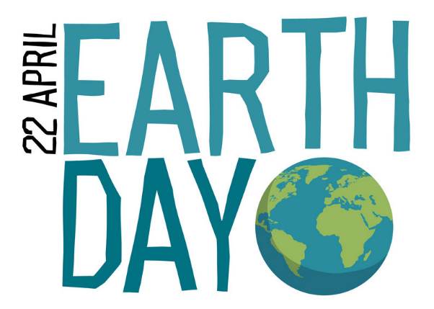
My Earth Day Pledge
Name & Surname: ________________

I PLEDGE TO: ____________________________________________________________________________________________________________________________________________________________________________________________________________

THIS IS IMPORTANT BECAUSE:
____________________________________________________________________________________________________________________________________________________________________________________________________________

Date: 22nd April _______
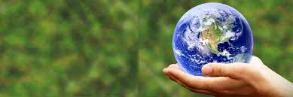
Signature: ____________________

